ss

**THUONG MAI UNIVERSITY**



**TOPIC: THE ROLE OF HUMAN ACTIVITIES IN CLIMATE CHANGE**

**Group 3:** **24­1_ENTH1511_24**

**Supervisor**: **MBA. Nguyen Thi Phuong Ly**

**THUONG MAI UNIVERSITY**

**GROUP DISCUSSION**

**ENGLISH 2**

**Topic: The role of human activities in climate change**

**Group:3**

**Class: 241_ENTH1511_24**

**Teacher: MBA.Nguyen Thi Phuong Ly**

**Group preparation assessment:** **Good**

**Presentation assessment: List of students (in the order of presenting)**

|  |  |  |  |
| --- | --- | --- | --- |
|  | **Name** | **Comment** | **Mark** |
| **1** | **Vu Thi Thu Hang** |  |  |
| **2** | **Nguyen Thi Phuong Hien** |  |  |
| **3** | **Pham Thi Huyen** |  |  |
| **4** | **Ngo Thi Hoa** |  |  |
| **5** | **Ho Minh Huyen** |  |  |

**MEETING MINUTES 1 - GROUP: 3**

**Time: 9 p.m, September 5, 2024.**

**Place:** google meet.

**Participants:** 5/5

**Contents for discussing:** make an outline and divide tasks

**Conclusion: Everyone agreed and with the teacher's feedback, the group created an outline and divided tasks for everyone.**

|  |  |
| --- | --- |
| **Leader** (Signature and name) | **Minute-Taker** (Signature and name) |
| **Huyen** | **Hien** |
| **Ho Minh Huyen** | **Nguyen Thi Phuong Hien** |

**MEETING MINUTES 2 - GROUP: 3**

**Time: 9 p.m, September 17, 2024**

**Place:** Google meet

**Participants:** 5/5

**Contents for discussing:** Good

**Conclusion: Everyone agreed and with the teacher's feedback, the group created an outline and divided tasks for everyone.**

|  |  |
| --- | --- |
| **Leader** (Signature and name) | **Minute-Taker** (Signature and name) |
| Huyen | Hien |
| Ho Minh Huyen | Nguyen Thi Phuong Hien |

**Task assignment table and member evaluation**

|  |  |  |  |
| --- | --- | --- | --- |
|  | **Name** | **Task** | **Point** |
| **1** | **Ho Minh Huyen** ( Leader) | **V + Powerpoint** |  |
| **2** | **Nguyen Thi Phuong Hien** (secretary) | **II + Word** |  |
| **3** | **Pham Thi Huyen** | **III + Word** |  |
| **4** | **Vu Thi Thu Hang** | **I + Word** |  |
| **5** | **Ngo Thi Hoa** | **IV + Powerpoint** |  |

**Introduction**

***1. Definition of Climate Change***

- Climate change refers to long-term shifts in temperature and weather patterns on Earth. It is driven by both natural processes and human activities, but recent changes are largely due to human actions such as burning fossil fuels and deforestation.

***2. Importance of Understanding Human Contributions***

- Recognizing how human activities contribute to climate change is crucial for addressing the problem effectively. Our actions, such as energy consumption and land use changes, significantly influence the climate. Understanding these contributions helps us implement strategies to reduce our impact and protect the environment.

***3. Purpose and Scope of the Assignment***

- This assignment aims to explore the role of human activities in climate change. It will cover the background of climate science, key activities contributing to climate change, their impacts, and mitigation strategies. Additionally, it will include case studies to illustrate successful actions and challenges in combating climate change.

**I. Background on Climate Change**

***1.1. Overview of Climate Science***

*1.1.1. Natural vs. Anthropogenic Factors*

 - Climate change is influenced by natural factors like volcanic eruptions and solar radiation, which have historically affected Earth’s climate. Volcanic eruptions can temporarily cool the Earth. However, since the Industrial Revolution, human activities, especially burning fossil fuels, have become the main driver of climate change. These activities release greenhouse gases such as CO₂, which trap heat and cause global temperatures to rise.

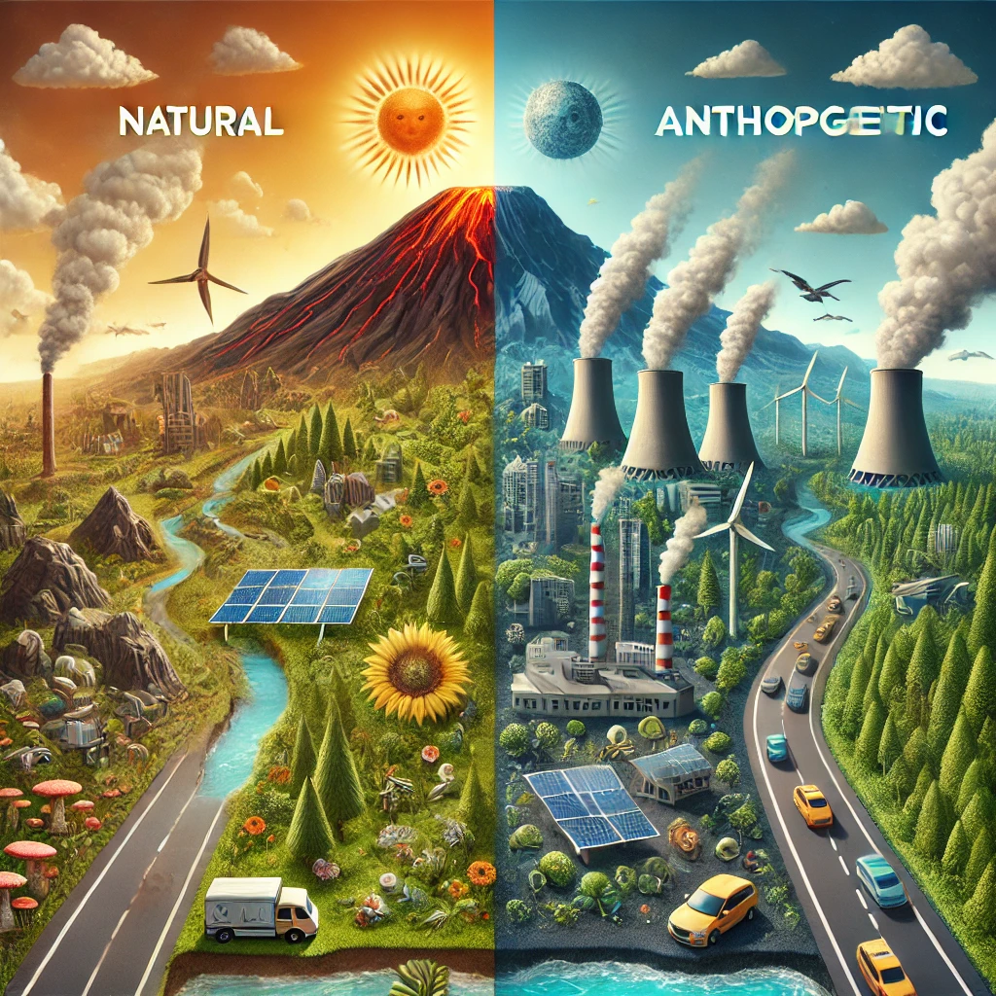

*1.1.2. Historical Climate Patterns*

 - Historically, Earth’s climate has experienced ice ages and warming periods. Scientists use ice cores and tree rings to study these changes. Current CO₂ levels are higher than at any point in the last 800,000 years. Unlike past gradual changes, today’s warming is happening much faster due to human activities, creating challenges for ecosystems and societies.

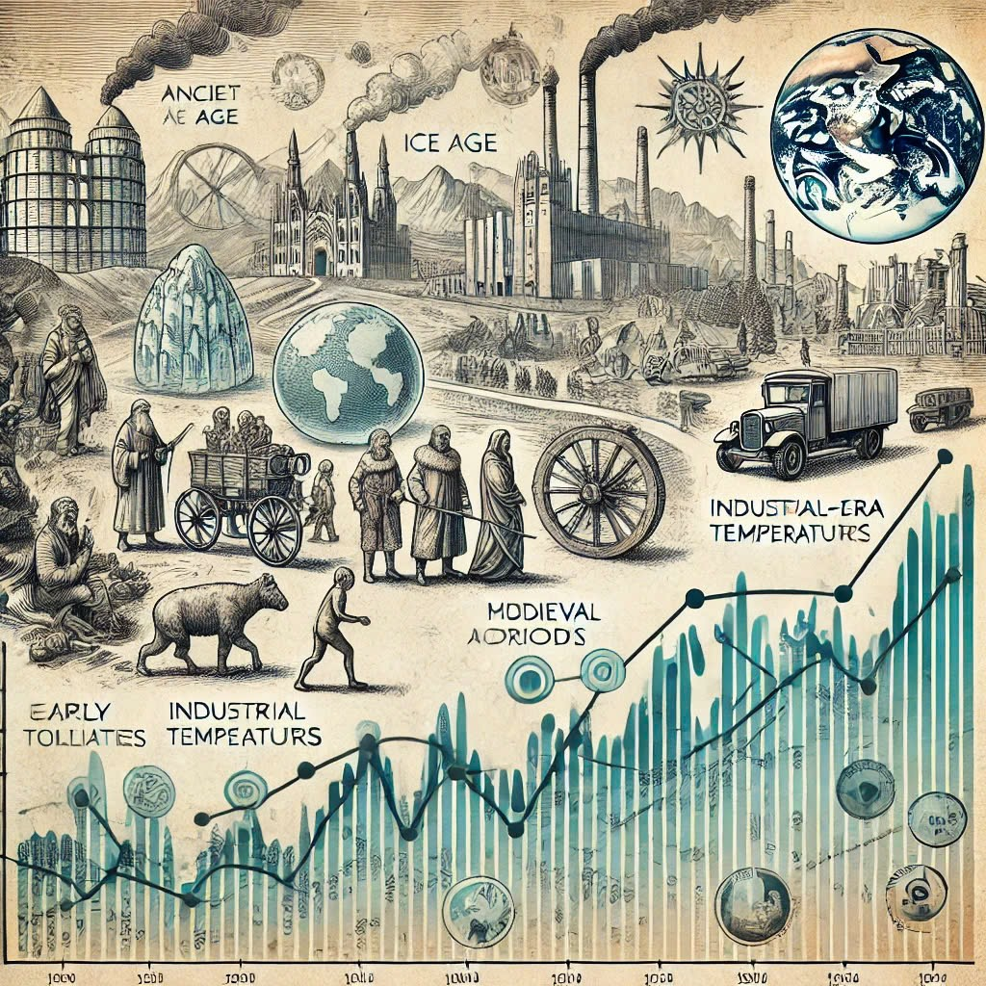

***1.2. Current State of Global Climate Change***

*1.2.1. Temperature Rise*

 -  The global temperature has increased by about 1.1°C since the late 19th century, mainly due to human activities. This warming affects weather patterns, causes ice to melt, and raises sea levels. It also impacts health, agriculture, and wildlife, with more frequent and severe heatwaves and changes in habitat conditions.

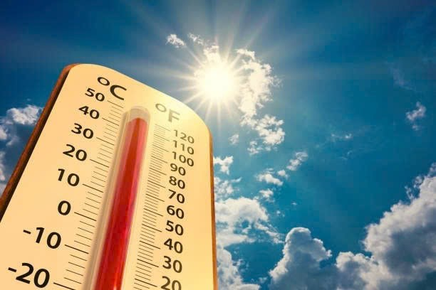

*1.2.2. Extreme Weather Events*

   Extreme weather events like hurricanes, floods, droughts, and wildfires are becoming more common and intense because of climate change. Warmer oceans and higher temperatures fuel stronger storms. These events damage communities and economies, making adaptation and mitigation essential to protect people and natural systems.

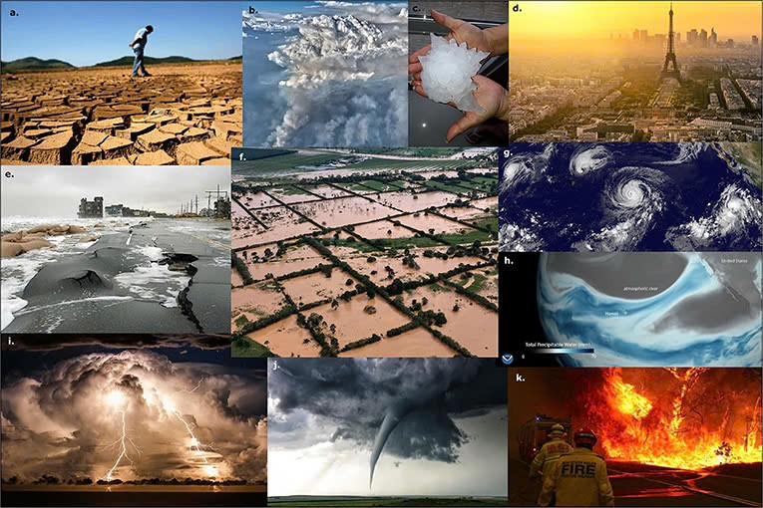

**II. Key Human Activities Contributing to Climate Change**

**2.1. Fossil Fuel Combustion**

Fossil fuels, such as coal, oil, and natural gas, are the primary drivers of climate change. When these fuels are burned, they release carbon dioxide (CO2), a potent greenhouse gas, into the atmosphere.

      2.1.1. Energy production

* The burning of fossil fuels to generate electricity is a major source of CO2 emissions. Power plants that rely on coal and natural gas are particularly significant contributors.
* Every year, burning fossil fuels releases about 21.3 billion tons of CO2. Half of this, or 10.65 billion tons, goes into the air, causing global warming and harming the environment. Gases like NO2 and SO2 cause acid rain, damaging crops and buildings. Coal is the worst offender, producing twice as much CO2 as natural gas and 30% more than gasoline.
* Air pollution from coal is a major cause of heart and lung diseases. People who are often exposed to coal dust can develop black lung disease, a condition that has no cure.

      2.1.2. Transportation

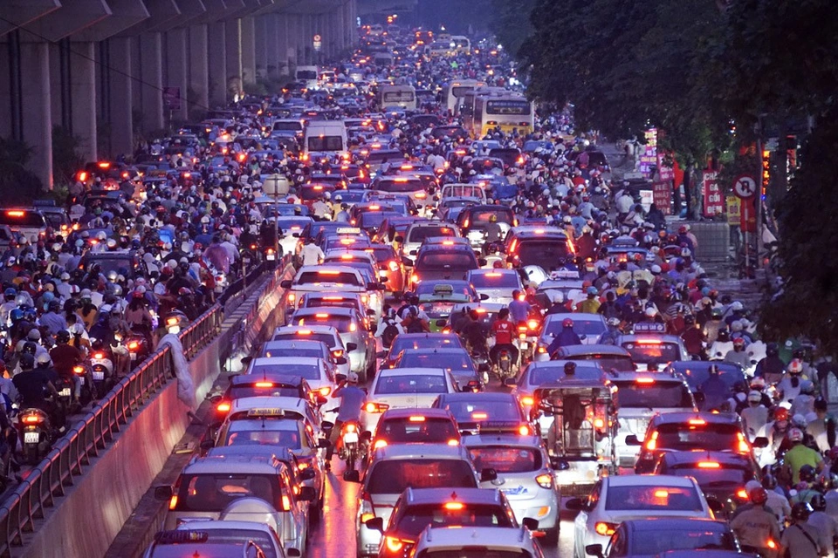

* Most cars, trucks, ships, and planes run on fossil fuels. This makes transportation a major source of greenhouse gases, especially carbon dioxide. Road vehicles are the biggest culprits, burning gasoline and other petroleum products. Even though ships and planes are also big polluters, their emissions are still increasing. In fact, transportation accounts for nearly a quarter of global energy-related CO2 emissions.
* Recent reports show that transportation accounts for about 25% of global carbon dioxide emissions.In large cities, severe traffic congestion has led to a surge in vehicle emissions.

**2.2. Deforestation**

Forests play a crucial role in regulating the Earth's climate by absorbing CO2 from the atmosphere. Deforestation, the clearing of forests for various purposes, reduces the planet's ability to absorb CO2, exacerbating climate change.

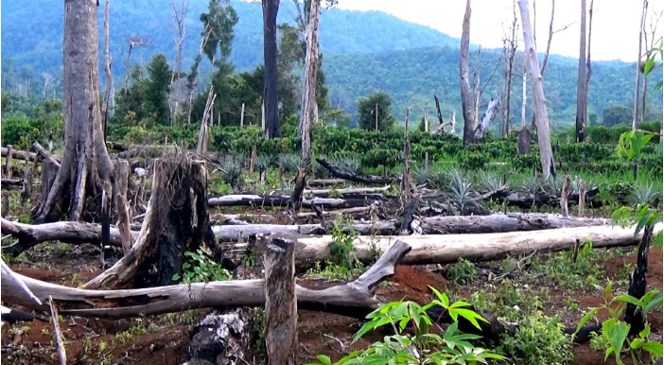

      2.2.1. Land use changes

* One of the primary drivers of deforestation is land use change. This refers to the conversion of forests into other land uses, such as agriculture, grazing, and urban development. As forests are cleared to make way for these activities, the carbon stored in the trees and soil is released into the atmosphere, primarily as CO2.

      2.2.2. Impact on carbon sinks

* Forests as carbon sinks**:** Forests act as the Earth's largest terrestrial carbon sinks, absorbing approximately 30% of human-caused carbon dioxide emissions.
* Carbon release: When forests are cleared, the stored carbon in trees and soil is released into the atmosphere, contributing to the greenhouse effect and global warming.

**2.3. Agriculture**

      2.3.1. Methane emissions from livestock

* Livestock, especially ruminants like cows and sheep, produce methane as a byproduct of their digestive process. Methane is a potent greenhouse gas, trapping much more heat in the atmosphere than carbon dioxide.
* According to the Clean Air and Climate Coalition, two-thirds of human-caused emissions come from livestock and fossil fuels. The rest is mostly from decomposing waste and rice cultivation.

      2.3.2. Nitrous oxide from fertilizers

* The excessive use of synthetic fertilizers in agriculture releases nitrous oxide into the atmosphere. Nitrous oxide is another potent greenhouse gas, contributing to both global warming and ozone depletion.
* Nitrous oxide emissions from fertilizers are on the rise due to improper farming practices. Many farmers, lacking adequate training and education, are applying fertilizers in excessive amounts and using incorrect methods. Not only does excessive fertilization lead to nutrient imbalances, but pollution from fertilizer production facilities also contributes to the problem.

**2.4. Industrial Processes**

      2.4.1. Emissions from manufacturing

* The production of goods often involves the combustion of fossil fuels like coal and natural gas, which release large amounts of carbon dioxide into the atmosphere. This is particularly evident in industries such as steelmaking, cement production, and refining. Furthermore, certain manufacturing processes, like the production of aluminum and other metals, can also release other greenhouse gases.
* 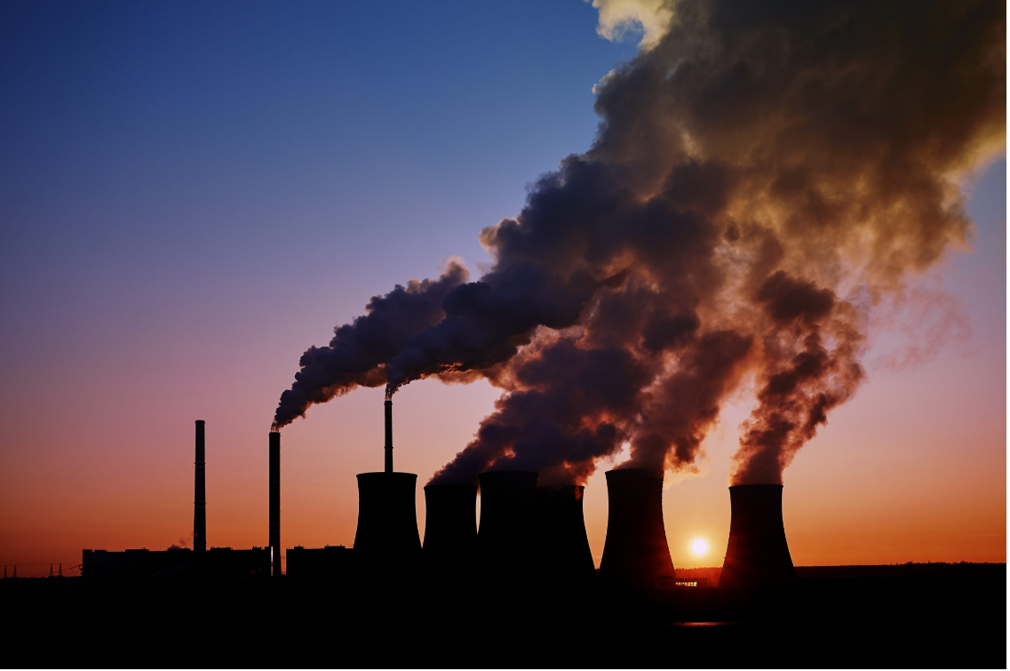

      2.4.2. Chemical production

* The chemical industry is another major contributor to greenhouse gas emissions. The production of various chemicals, including fertilizers, plastics, and refrigerants, involves complex chemical reactions that release greenhouse gases. For instance, the production of refrigerants, such as hydrofluorocarbons (HFCs), is a significant source of emissions. These substances are potent greenhouse gases, meaning they trap heat in the atmosphere far more effectively than carbon dioxide.

**III. THE IMPACT OF HUMAN ACTIVITIES ON CLIMATE CHANGE.**

**3.1. Greenhouse Gas Emissions.**

Greenhouse gases (GHGs) trap heat in the Earth's atmosphere. They allow sunlight to enter the atmosphere freely but prevent some of the heat that the Earth reflects from escaping into space. This natural greenhouse effect is crucial for maintaining suitable temperatures for life on Earth. However, human activities have significantly increased the concentration of certain greenhouse gases, contributing to global warming and climate change.

3.1.1. Types of gases (CO₂, CH₄, N₂O).

* - Carbon Dioxide (CO2): Carbon dioxide enters the atmosphere through burning fossil fuels (coal, natural gas, and oil), solid waste, trees, and other biological materials, and it is also a result of certain chemical reactions.
* - Methane (CH4): Methane is emitted during coal, natural gas, and oil production and transportation. Methane emissions also occur from livestock and other agricultural activities, land use, and the decomposition of organic waste in municipal landfills.
* - Nitrous Oxide (N2O): Nitrous oxide is emitted during agricultural, land use, and industrial activities; combustion of fossil fuels and solid waste; as well as during treatment of wastewater.

3.1.2. Sources and global trends.

- The greenhouse effect was discovered by scientist Joseph Fourier in 1824, the first reliable experiment was conducted by scientist John Tyndall in 1858, and a thorough quantitative report was carried out by scientist Svante Arrhenius in 1896.

- For the environment, the greenhouse effect is a term used to describe the phenomenon of heat-trapping in the Earth's atmosphere due to the inability of some sunlight to be reflected out.

* - Research from respiratory specialists at Royal Brompton Hospital in the United Kingdom has shown that the greenhouse effect causes significant harm to human health, including an increased risk of respiratory diseases and mental health issues.
* - The greenhouse effect is a clear example of how human activities can impact the global environment. It highlights the connection between actions in a specific geographical area and global consequences. It serves as evidence of the importance of prevention rather than waiting to fix problems. By reducing emissions and protecting the environment, we can prevent or mitigate negative impacts on ecosystems and the economy.

**3.2. Feedback Loops**

3.2.1. Melting ice caps.

-Ice at the poles is gradually melting due to rising temperatures on Earth. It does not melt bit by bit at the surface; instead, it cracks into floating pieces in the ocean before completely melting.

-The melting ice also leads to habitat loss for many animal species, pushing them closer to the brink of extinction and causing imbalances in the natural world.  It also raises sea levels, indirectly leading to saltwater intrusion in coastal areas and increasing the risk of flooding in large land areas, thereby shrinking living space for humans.

- The negative impacts of melting ice are affecting people's lives every day. Therefore, we need to have reasonable and long-term policies to combat the greenhouse effect to halt the melting process at the two poles.

* 3.2.2. Changes in albedo effect.
* - In simple terms, the albedo effect relates to the ability of different surfaces to reflect sunlight back into space (known as planetary albedo). Light-colored surfaces, classified as having high albedo, can reflect a large portion of sunlight, while dark-colored surfaces, known as having low albedo, absorb more solar radiation.
* - The Earth's albedo has been gradually decreasing over recent decades, a trend contributing significantly to global warming. This reduction in albedo can be attributed partly to the long-term increase in Earth's average surface temperatures, known as global warming. Caused mainly by human-induced emissions of greenhouse gases, global warming reduces albedo, which in turn leads to further warming. This creates a feedback loop, a vicious cycle accelerating the rate of climate change.

**IV. Mitigation Strategies**

**4.1. Renewable Energy Sources**

***4.1.1Solar, wind, and hydroelectric power***

* Renewable energy sources like solar, wind, and hydroelectric power are key solutions to reducing climate change. Solar power uses sunlight to create electricity, while wind power uses the wind to turn turbines that generate energy. Hydroelectric power comes from water flowing through dams. These energy sources do not produce greenhouse gases, making them much cleaner than fossil fuels like coal or oil. By using more renewable energy, we can reduce the amount of carbon dioxide and other harmful gases in the atmosphere, helping slow global warming.

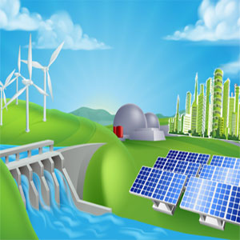

* The calculations on how much CO2 could be saved by wind energy are based on an assumption for the carbon intensity of the global electricity sector, i.e. the typical amount of CO2 emitted by producing one kWh of power. This would result in annual CO2 savings of more than 1.5 billion tons in 2020 and 3.2 billion tons in 2030.
* **4.2. Sustainable Agriculture Practices**
  + 1. **Crop Rotation and Agroforestry**



* Sustainable agriculture means farming in ways that protect the environment and reduce greenhouse gas emissions. Crop rotation is one such practice where different crops are planted in a specific order on the same land. This helps keep the soil healthy and reduces the need for chemical fertilizers, which can produce nitrous oxide, a powerful greenhouse gas.

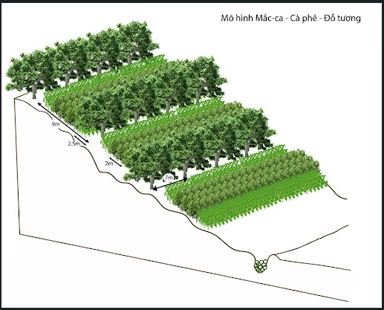

* Agroforestry is another practice that involves planting trees and crops together. Trees can absorb carbon dioxide from the air, and their roots help keep the soil in place, reducing erosion. Both of these practices can help make farming more environmentally friendly and reduce its impact on climate change.
* **4.3. Reforestation and Afforestation**
* Reforestation and afforestation are important strategies for fighting climate change. Reforestation means planting trees in areas where forests have been cut down, while afforestation means planting trees in areas that did not have forests before. Trees play a crucial role in absorbing carbon dioxide from the atmosphere, which helps reduce the amount of this greenhouse gas. By planting more trees, we can create new carbon sinks - places where carbon is stored instead of being released into the air. This can help balance the levels of carbon dioxide in the atmosphere and slow down global warming.

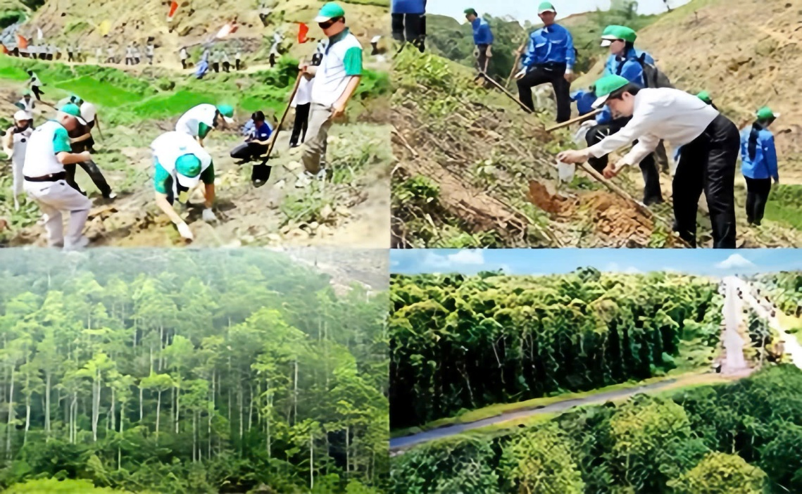

* Vietnam is making significant strides in this effort. Public awareness of the importance of trees has grown considerably. The movement to reforest barren hills in Vietnam is gaining momentum, with people from all corners of the country coming together to plant trees. This widespread community involvement is making a positive impact on our environment.
* **4.4. Policy and Regulation**
* **4.4.1. International Agreements (e.g., Paris Agreement)**
* Governments around the world need to work together to tackle climate change. The Paris Agreement is one of the most important international agreements on climate change. It was signed by many countries in 2015, and its goal is to keep global warming below 2°C, and ideally below 1.5°C, compared to pre-industrial levels. To achieve this, countries agreed to reduce their greenhouse gas emissions and report on their progress regularly. International cooperation is essential because climate change is a global problem that requires a united effort.
*      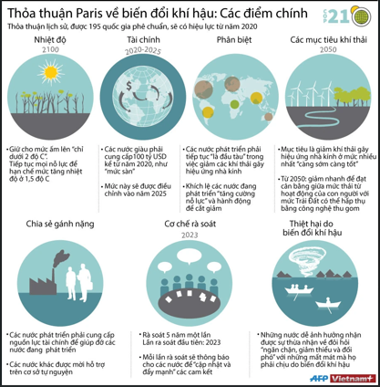

**4.4.2. National and Local Initiatives**

* Besides international agreements, national and local governments also need to take action. Many countries have introduced policies to encourage the use of renewable energy, reduce emissions from transportation, and protect forests.

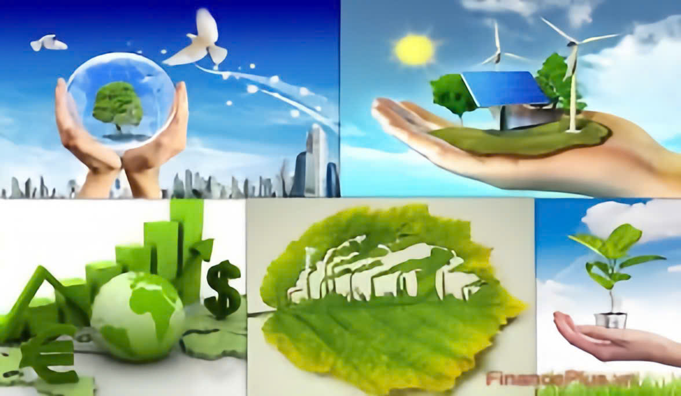

* For example, some governments offer incentives for people to buy electric vehicles or install solar panels in their homes. Local initiatives, like citywide recycling programs or tree-planting projects, also play an important role in reducing emissions and helping communities become more sustainable. By working at all levels international, national, and local we can make significant progress in the fight against climate change.

V. Case Studies

**5.1. Successful mitigation examples**

5.1.1. Countries leading in emissions reduction

- Sweden: Sweden is one of the top countries working hard to reduce its impact on climate change. It has set a goal to have zero greenhouse gas emissions by 2045. Sweden gets more than half of its energy from renewable sources like wind and water. The country also introduced a carbon tax in 1991, which means companies have to pay for the pollution they cause. This tax has helped Sweden lower its emissions and can be an example for other countries.

- Costa Rica: Costa Rica is another country doing well in the fight against climate change. The country produces over 98% of its electricity from clean, renewable sources like hydroelectric power. Costa Rica also plants many trees to help absorb carbon dioxide from the air. This helps the country work towards its goal of becoming carbon neutral by 2050, meaning it will not add any extra carbon dioxide to the atmosphere.

5.1.2. Innovations in technology

- Carbon Capture and Storage (CCS): This is a new technology that helps reduce the amount of carbon dioxide (CO₂) in the air. It works by capturing CO₂ from power plants and factories and storing it deep underground where it cannot escape into the atmosphere. One of the first big projects using this technology is in Norway, called the Sleipner project. It has successfully stored millions of tonnes of CO₂, helping to reduce the impact on the climate.

- Electric Vehicles (EVs): Electric vehicles (EVs) are cars that run on electricity instead of gasoline or diesel. They are much cleaner because they do not produce greenhouse gases while driving. Countries like Norway and the Netherlands are leading the way in using electric vehicles. The governments in these countries support the use of EVs by offering incentives like lower taxes and building many charging stations. This makes it easier for people to switch from traditional cars to electric ones.

**5.2. Challenges and setbacks**

5.2.1. Political resistance

- United States: The United States is one of the biggest producers of greenhouse gases, but it faces many political challenges in reducing them. For example, during the presidency of Donald Trump, the U.S. left the Paris Agreement, a global deal to fight climate change. This slowed down efforts to reduce emissions. Although the U.S. rejoined the agreement under President Joe Biden, political disagreements and the influence of the fossil fuel industry make it hard to pass strong climate laws.

- Australia: Australia also has difficulties in reducing emissions because of political resistance. The country relies a lot on coal, which is a big source of pollution, for its economy. Even though Australia is affected by climate change, like with dangerous bushfires, the government has been slow to take strong action because of the economic importance of coal.

5.2.2. Economic factors

- Developing Countries: Many developing countries, like India, face economic challenges that make it hard to reduce emissions. These countries often rely on cheap energy from coal to grow their economies. Switching to cleaner energy sources like wind or solar can be expensive, so these countries need help from richer nations to make this change.

- Global Economic Recessions: Economic problems, like the 2008 financial crisis or the COVID-19 pandemic, can slow down efforts to fight climate change. During tough economic times, governments and businesses often focus more on fixing the economy than on reducing emissions. This can delay the progress of moving towards a more sustainable future.

Conclusion

1. Summary of human impacts on climate change

- Human activities are the main cause of the climate change we see today. Burning fossil fuels for energy, cutting down forests, and certain farming practices release a lot of greenhouse gases, like carbon dioxide and methane, into the atmosphere. These gases trap heat, making the Earth warmer and causing problems like rising sea levels, extreme weather, and changes in ecosystems.

2. Call to action for individuals and policymakers

- To slow down climate change, everyone needs to do their part. Individuals can make small but important changes, like using less electricity, recycling, using public transport, and planting trees. These actions help reduce the amount of greenhouse gases we produce. Policymakers also play a crucial role. They need to create strong laws and policies that encourage the use of renewable energy, protect forests, and support sustainable farming. International cooperation is also important because climate change is a global problem that needs global solutions.

3. Future outlook on climate change and human responsibility

- The future of our planet depends on the choices we make today. If we take action now, we can reduce the effects of climate change and protect the environment for future generations. It is our responsibility to care for the Earth and make decisions that lead to a cleaner, safer, and more sustainable world. We still have time to make a difference, but we must act quickly and work together to achieve this goal.